 | Emerging NREN Programme  Form | 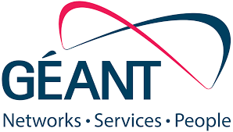

Name
Surname
Country
Email Address
Phone Number  WhatsApp Number | (+ ___ )  (+ ___ )
NREN/ Organisation
Position

Please attach your CV to this form.

Why would you like to participate to the Emerging NREN programme and TNC26? (max 150 words)

Topics of interest during the TNC26 Conference?

Have you ever participated in TNC? (If so which year)

Have you submitted a Lightning Talk or SIG proposal? (If yes please indicate the title)

Language, Fluency (Intermediate, Advanced, Native)
1. |  | 3.
2. |  | 4.

Do you need a visa to enter Finland?

Participants obligations - long term impact evaluation
By participating in the Emerging NREN program you commit to:
- Submit a lightning talk by the 10th of March 2026,
- Attend all dedicated ENP activities alongside TNC,
- Submit a two-page report detailing your experience within two weeks of return and an evaluation survey,
- GÉANT will also contact participants 6-12 months after the end of the program in order to evaluate the long-term impact of ENP.

